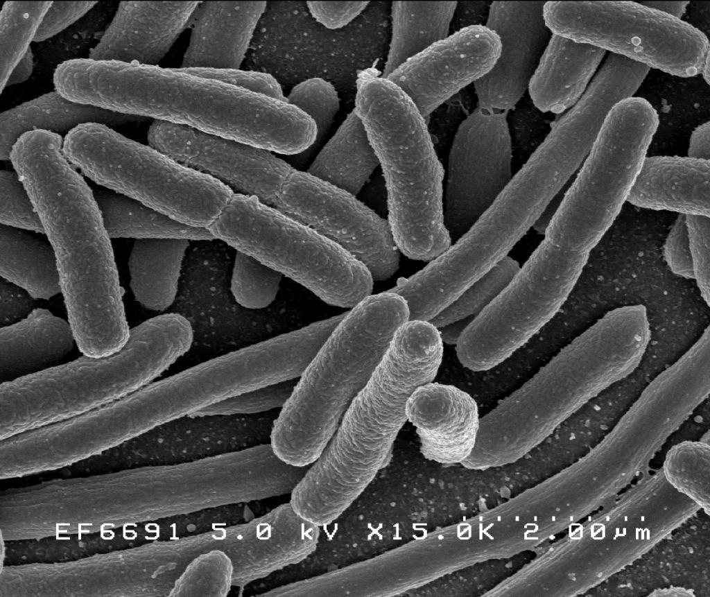

Fast Accurate Detection of E. Coli

System Proposal and Design (WORKING DRAFT)

# Executive Summary

Over the course of the 2017 Fall semester this team developed a partial systems design and management program for a system that can detect the presence of E. coli on food products being prepared at restaurants.

**Customer’s statement of need:**

*In the United States there are 47 million cases of foodborne illness a year, 128,000 of those cases result in hospitalization and another 3,000 result in death; these cases cost the Medical and Food industries billions of dollars annually. There is a need for a device in the food industry that will rapidly detect the E.Coli pathogen that leads to foodborne illness in a product. The developed system for detecting harmful E.Coli pathogens will alert the user if there is are more than zero colony-forming units (cfu) per 100mL of fluid or 25g of solid (BAM 4: Enumeration of Escherichia coliand the Coliform Bacteria) as designated by the FDA. The system needs to be cost effective, portable, efficient, and easy to use for all potential customers. The design needs to be provided no later than December 2017, with prototype delivered by December 2018.*

**Design Summary**

The FADE system employs an Infrared (IR) Raman spectroscopy analytical technique to detect the presence of E. coli on food products based on the chemical “fingerprint” of the pathogen. This technique has been proven in the laboratory in the application but has yet to be incorporated into a consumer product.

**Development Program Summary**

The hypothetical development program for this system was limited to the Fall 2017 semester. It consisted of five phases: Conceptual Design, Preliminary Design, Detail Design, Production, and Maintenance. We estimate that the design phases of the project would cost approximately $1.77M and production of 10000 units would cost $15.5M. Pricing for full cost recovery would be approximately $1,730, slightly less than the team target of $2,000 for an instrument of this type being sold to restaurants.

1. Table of Contents

**1.** **Executive Summary 2**

**2.** **Project Schedule 5**

**3.** **Conceptual Design Phase 6**

3.1. Customer selection graphic 6

3.2. KPP table 7

3.3. Stakeholder Requirements 7

3.4. System-level Analysis of Alternatives 7

*3.4.1.* *IR Raman 8*

*3.4.2.* *Hyperspectral Imaging (HSI) 8*

*3.4.3.* *CO2 Detection 8*

*3.4.4.* *Mass-sensitive Biosensor 9*

3.5. Subsystem Analysis of Alternatives 10

**4.** **Preliminary Design Phase 13**

4.1. Functional Architecture 13

4.1. System Requirements 19

4.2. Functional Requirement Allocation 21

4.3. Physical Architecture 22

**5.** **Detail Design Phase 24**

5.1. Risk Management 24

5.1. Verification Plan 27

**6.** **Production Phase 28**

6.1. 3.1 Production 28

6.2. 3.2 Cost 28

**7.** **Maintenance Phase 31**

**8.** **References 31**

1. Table of Figures

Figure 1 - Project Phases 5

Figure 2 - Customer Selection 6

Figure 3 - Through Package Sampling 12

Figure 4 - Vial Based Sampling 12

Figure 5 - System Functional States 13

Figure 6 – Diagram of State 1: Normal Operation 13

Figure 7 – Diagram of Function 1.0: Activate Device 14

Figure 8 – Diagram of Sub-Functions 1.3 & 1.4: Conduct Self Test & Handle Self Test Results 15

Figure 9 – Diagram of Function 2.0: Sample Food Product 16

Figure 10 – Diagram of Function 3.0: Analyze Sample 16

Figure 11 – Diagram of Function 4.0: Inform Operator 16

Figure 12 – Diagram of Function 5.0: Store Results 17

Figure 13 – Diagram of Function 6.0: Go into Standby 17

Figure 14 – Diagram of Function 7.0: Maintain Device 17

Figure 15 – Diagrams of States 2 & 3: Charge Battery & Service Mode 18

Figure 16 – Physical Architecture 22

Figure 17 - Cost and Schedule 29

Figure 18 – Cost Calculations 30

Figure 19 – After Sales Support 31

1. Table of Tables

Table 1 - List of Abbreviations 5

Table 2 - Key Performance Parameters 7

Table 3 - Alternative System Comparison 9

Table 4 - Alternative Subsystem Battery Comparison 10

*Table 5 - Alternative Subsystem Display Comparison* 11

*Table 6 - Alternative Subsystem Sampling Mode Comparison* 11

Table 7 - System Functional Requirements 19

Table 8 - System Performance Requirements 20

Table 9 - System Design Requirements 20

Table 10 – Functional Allocation to System Design Requirements 21

Table 11 – Functional Allocation to Physical Architecture 23

Table 12- Risk Management 25

Table 13 - Risk Cube 26

Table 14 – Technical Performance Measures 27

Table 15 - Cost Assumptions 30

|  |  |
| --- | --- |
| Abbreviation | Definition |
| CDC | Center for Disease Control and Prevention |
| CDR | Conceptual Design Review |
| CFU | Colony Forming Unit |
| DDR | Detailed Design Review |
| FADE | Fast Accurate Detection of E. Coli |
| FTIR | Fourier-transform Infrared |
| IR | Infrared |
| KPP | Key Performance Parameter |
| R&D | Research and Development |
| SERS | Surfaced-enhanced Raman Spectroscopy |
| WEEE | Wasted Electrical and Electronic Equipment |

*Table 1 - List of Abbreviations*

# Project Schedule

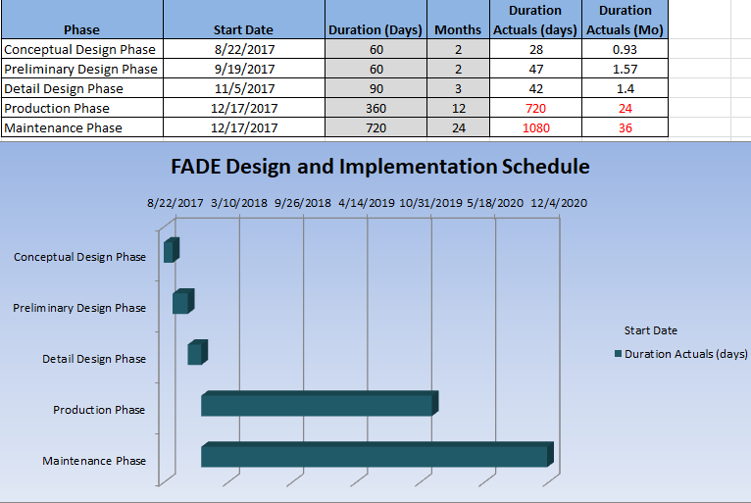

*Figure 1 - Project Phases*

# Conceptual Design Phase

## Customer selection graphic

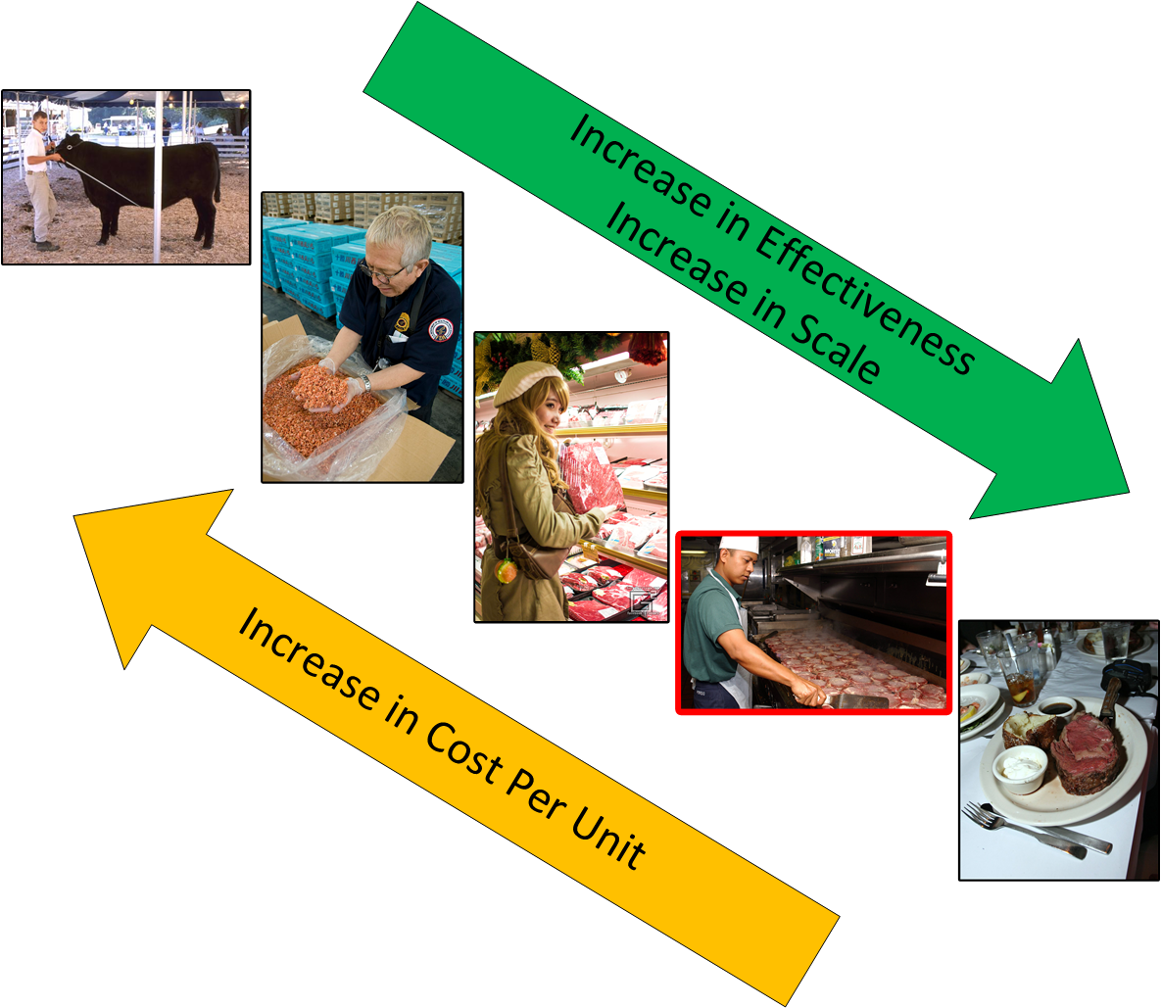

*Figure 2 - Customer Selection*

## KPP table

|  |  |
| --- | --- |
| **Key Performance Parameters (KPPs)** | **Rank** |
| Speed | 1 |
| Accuracy | 2 |
| Usability | 3 |
| Affordability | 4 |
| Portability | 5 |
| Durability | 6 |
| Maintainability | 7 |

## 

*Table 2 - Key Performance Parameters*

## Stakeholder Requirements

1. The device shall be able to detect E.coli in the food product.
2. The device shall be able to detect E.coli rapidly.
3. The device shall be affordable.
4. The device shall be light.
5. The device shall be portable.
6. The device shall be easy to operate.
7. The device shall be battery operated.

## System-level Analysis of Alternatives

During the initial analysis of the potential marketability and profitability of a system of this kind, it was determined that the targeted end user should be restaurants and that we should employ proven laboratory analytical techniques. We considered four primary factors. First, FADE’s effectiveness in keeping consumers from consuming potentially harmful pathogens or allergens. We determined that providing a detection capability further downstream in the material chain towards the consumer would be beneficial. Second, we considered the feasibility employing the technology in the system and opted to positively weigh high technology readiness in order to reduce time to market. Third, the system must be affordable for the intended end user. Finally, the system should allow for future expansion either into different markets and/or detect additional materials of concern.

We determined that the primary system design driver would be the sensor technology employed due to differences in sample preparation, analysis time, contact vs. non-contact, instrument size, and accuracy. Subsequent sub-system alternative studies could only be completed once we determined which sensor best met the needs of our end user as the primary.

**Alternate Sensor Options**

Multiple sensor technologies could be used by this system. We recommend the use of Infrared Raman (IR Raman) Spectroscopy based on initial system-level trade off analysis. IR Raman spectroscopy is being successfully used in various handheld material identification systems and current research indicates it can be applied to detect E. Coli. We arrived at this recommendation through considering the alternatives presented below along with the currently fielded system, Table 3.

### IR Raman

Fourier-transform infrared (FTIR) and Raman spectroscopy search an area for a “‘fingerprint signature for bacteria identification” (Hong et al., 2016, p. 513). The use of an infrared system would allow for the identification of bacteria in a product. Enhanced Raman spectroscopy (SERS) “requires direct contact of the sample with the substrate” (Hong et al., 2016, p. 513), and processing time is based on the area of the test sample. There are portable Raman spectrometers on the market currently, therefore, technology needed is already available. It would be feasible to mass produce small versions of Raman spectrometers.

### Hyperspectral Imaging (HSI)

Hyperspectral imaging uses near-infrared (NIR-HIS) scanners to obtain images for detection and differentiation of bacteria. The imaging “provided characteristic spectral signatures” which can be used to detect and identify bacteria. (Kammies et al., 2016, p. 9305). This is a lab based technology which relies heavily on software to classify the bacteria. The time to call depends on the availability of the software and database data mining to identify the bacteria. The accuracy of the system depends on the size of the spectral data, quality of light scattering and the data differentiations, (Chen et al., 2015, p.481). Seeing as this method relies on software and imaging, the system would likely cost more as the imaging system and software abilities would not want to be compromised.

### CO2 Detection

Carbon dioxide detection is a means of detecting the presence of bacteria in a sample but does not allow for identification. As bacteria grow they release CO2, higher concentrations of CO2 promote higher growth rates of bacteria. This test method is primarily used in research and for determining bacterial presence in a clinical setting. It is a time consuming process as it requires sample incubation, (Amanatiou et al., 1999).  The cost of the system depends on the features of the incubator, including thermal conductivity, desiccation, contamination, etc. (Varisanga et al., 2002, p. 78). Seeing as this method is time consuming and does not allow for the identification of the bacteria in a product this option should not be pursued.

### Mass-sensitive Biosensor

A mass sensitive biosensor uses a piezoelectric sensor which is coated with an antibody that would detect the presence of a specific pathogen in a solution. If the specific pathogen is present in the solution, it would attach to the antibodies on the sensor, resulting in an elevated crystal mass. The increase in mass would be detectable using a mass sensitive biosensor. An advantage of using a mass sensitive biosensor is that they can be easily mass produced using piezoelectric materials. The most common piezoelectric material used for these sensors is quartz. Although piezoelectric quartz is available on the market, dependency of quartz to be developed and manufactured as the key component of the system means that the overall cost of the system would rely heavily on the availability and cost of the quartz. The capability of the sensors is dependent upon the test media, “Ability of the sensor to detect the target material or analyze in the medium is superior under flow conditions” (Velusamy et al., 2010, p. 247). The system would require the user to create a liquid media sample for testing. The system would also be reusable but would require thorough cleaning between testing. Different components of system can be sold separately (ex. surface fluid to coat quartz).

|  |  |  |  |  |  |  |
| --- | --- | --- | --- | --- | --- | --- |
| **KPP** | **KPP Rank** | **KPP Weight** | **IR Raman** | **Mass-sensitive Biosensor** | **Hyperspectral Imaging** | **CO2 detection** |
| Capable of detecting harmful E-Coli within seconds | 1 | 0.25 | 9 | 9 | 9 | 9 |
| Near 100% accuracy | 2 | 0.25 | 5 | 5 | 5 | 1 |
| Bright display and audible alert for detection results | 3 | 0.2 | 3 | 3 | 3 | 3 |
| Small, light, hand held and battery powered | 4 | 0.1 | 9 | 5 | 5 | 9 |
| Easy to maintain and clean | 5 | 0.1 | 9 | 5 | 9 | 9 |
| Strong plastic makes it extremely durable | 6 | 0.05 | 9 | 5 | 5 | 9 |
| Versatile - Operates in nearly any climate | 7 | 0.05 | 5 | 5 | 5 | 3 |
| **Totals** |  | **1.00** | **6.6** | **5.6** | **6** | **5.5** |

*Table 3 - Alternative System Comparison*

## Subsystem Analysis of Alternatives

Considering the stakeholder requirement of the system being handheld, we performed an alternative analysis on two types of batteries to power the system; lithium ion and lead acid.

The KPP used to perform the subsystem comparison of alternatives were derived from the need statement and stakeholder requirements.

|  |  |  |  |
| --- | --- | --- | --- |
| **KPP / Alternative** | **KPP Weight** | **Lead Acid** | **Lithium Ion** |
| Safety | 0.20 | 9 | 1 |
| Life Cycle | 0.20 | 1 | 9 |
| Cost | 0.15 | 9 | 3 |
| Available Power | 0.15 | 3 | 9 |
| Charge Time | 0.10 | 3 | 5 |
| Weight | 0.10 | 3 | 5 |
| Size | 0.10 | 3 | 9 |
| **Totals** | **1.00** | **4.7** | **5.7** |

*Table 4 - Alternative Subsystem Battery Comparison*

The use of touch sensitive displays and touch surfaces has immensely increased and rapidly replacing physical buttons.  Physical buttons are cumbersome as they take more effort to utilize, lack in speed and accuracy, are sensitive to environment, have a much shorter life, and difficult to keep clean.  Touch displays are growing rapidly due to speed, accuracy, flexibility, space and cost savings.  Most current touch displays are capable of providing tactile and audio feedback which creates the perception of touching physical buttons, but at a much faster response, improving user performance, productivity and safety, while at the same time reducing the effect of a device complexity.

The sub-system alternatives study will be performed on the following touch screen technologies:

**Resistive Touch** - pressure-activated by any object, tactile feel, low cost and power, vulnerable to scratches

**Capacitive Touch** - electrical charge-activated such as bare finger, stylus or surgical glove, tactile feel, simultaneous input, resistant to scratches

**Surface Acoustic Wave (SAW) Touch** - uses piezoelectric transducers and receivers, activated by any object including liquid droplets (not feasible for this project, as it fails to comply with primary KPP of versatility, functional in moisture environments)

**Infrared (IR) Touch** - activated by any object, vulnerable to accidental activation, sensitive to water and ambient light interference, very high cost

The KPP used to support the comparison of these alternatives were derived from the need statement and stakeholder requirements, eventually generating additional requirements identified in the following section as subsystem alternatives. The preferred touch screen display based on the results driven by the subsystem alternatives is capacitive touch display.

|  |  |  |  |  |
| --- | --- | --- | --- | --- |
| **KPP / Alternative** | **KPP Weight** | **Resistive touch** | **Capacitive touch (finger only)** | **Infrared touch** |
| Speed (how fast it transmits) | 0.20 | 5 | 9 | 9 |
| Durability | 0.20 | 3 | 9 | 9 |
| Cost | 0.15 | 9 | 5 | 1 |
| Accuracy | 0.15 | 5 | 9 | 9 |
| Power consumption | 0.10 | 9 | 5 | 3 |
| Sensitivity (touch) | 0.10 | 3 | 5 | 3 |
| Resistance (external factors such as humidity, chemicals, etc) | 0.10 | 9 | 9 | 3 |
| **Totals** | **1.00** | **5.8** | **7.6** | **6** |

*Table 5 - Alternative Subsystem Display Comparison*

IR Raman sensors function by collecting and characterizing IR emissions from a sample that is being illuminated with a laser. These sensors can sometimes be used in a non-contact mode or through the packaging of the material (if the packaging is sufficiently transparent). However, preparation of a sample through mixing and dilution of the sampled material may provide a better result. Additionally, the vials or other containers required to contain the sample may be constructed from glass or clear plastic. Our analysis of alternatives is provided in Table 8. We recommend a parallel pursuit of the non-contact and disposable plastic vial alternatives through preliminary design in order to determine whether the non-contact alternative has an acceptable level of efficiency.

|  |  |  |  |  |  |  |
| --- | --- | --- | --- | --- | --- | --- |
| **KPP / Alternative** | **KPP Weight** | **Non-**  **Contact** | **Through Packaging** | **Within the Equipment** | **Reusable Glass Vial** | **Disposable Plastic Vial** |
| Detection efficiency | 0.3 | 1 | 5 | 9 | 9 | 9 |
| Cross-contamination risk | 0.3 | 9 | 5 | 1 | 5 | 9 |
| Cost | 0.2 | 3 | 3 | 3 | 3 | 1 |
| Cleanliness (sanitizing) | 0.2 | 9 | 3 | 1 | 5 | 9 |
| **Totals** | **1.00** | **5.4** | **4.2** | **3.8** | **5.8** | **7.4** |

*Table 6 - Alternative Subsystem Sampling Mode Comparison*

Based on the KPPs used to perform a subsystem alternative comparison, the non-contact sampling methods scored highest on cleanliness and the associated cross-contamination risk since no part of the system need come in contact with the food being tested. However, this sampling mode is the least efficient. IR Raman detection requires the elimination of the very strong Rayleigh scattered radiation while detecting weak Raman scattered radiation. (Larkin 2011) This means that consistent and predictable sampling is critical for accurate E. coli detection. A non-contact IR Raman instrument being used by a marginally trained operator may prove to be ineffective. Additionally, Rayleigh scattering can be especially strong, and therefore degrading, if the laser passes through a gas, like air, as would be the situation for a non-contact system.

While employing a through-packaging sampling mode reduces or eliminates some detection noise contributors it presents additional system-level challenges. The packaging materials need to be sufficiently transparent which would require compliance by food wholesalers. This would probably lead to higher food supply costs and reduced supplies options. The illuminator/detector head would still require cleaning due to the possibility of contamination on the surface of the packaging materials.

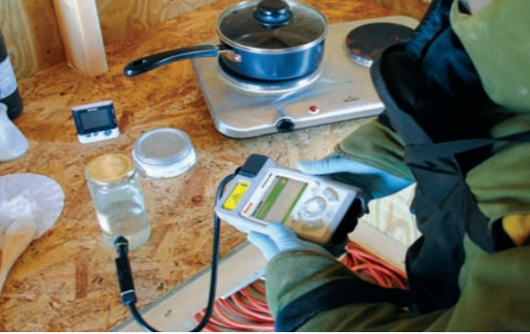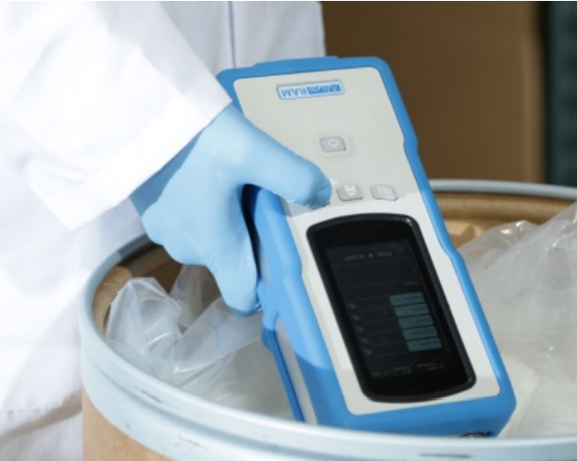

*Figure 3 - Through Package Sampling*

Conversely placing a sample of the food being tested directly into a sampling port may provide the best detection efficiency but would present additional maintenance complications, likely resulting in cross contamination. Placing the sample in a reusable glass vial or disposable clear plastic vials solves much of the cross-contamination concerns but requires either the disposal of the vial after use or a thorough cleaning of the vial.

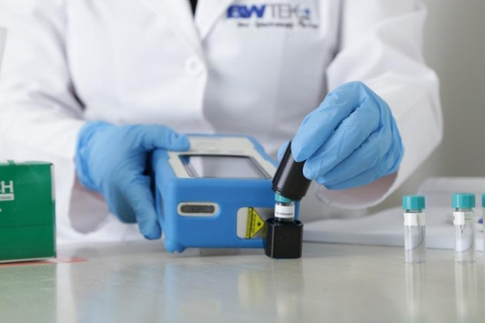

*Figure 4 - Vial Based Sampling*

# Preliminary Design Phase

## Functional Architecture

The FADE will have three functional states (Figure 2). Normal Operation (State 1) will be active when the device is being used to detect food contamination. Charge Batter (State 2) will be active when the device operator connects the device to the battery charging connection. Service Mode (State 3) will be active if the device memory needs to be managed, firmware needs to be updated, or if technical support needs to further diagnose a device failure.

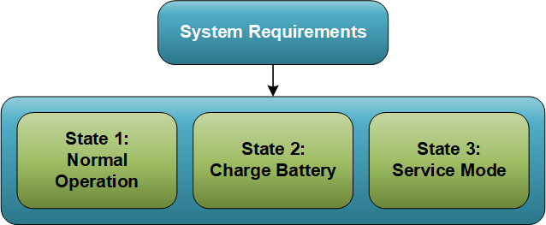

*Figure 5 - System Functional States*

During normal operations the device will operate in a functional loop shown in Figure 3.

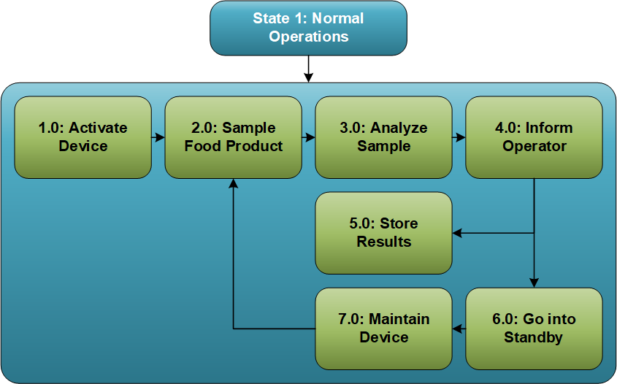

*Figure 6 – Diagram of State 1: Normal Operation*

In Function 1.0: Activate Device (Figure 4 with sub-functions in Figure 5) the device will be powered on and will conduct self testing of critical subsystems and components. If an error is detected (a NO GO condition) the user will implement a set of troubleshooting steps to attempt to resolve the fault condition prior to contacting technical support.

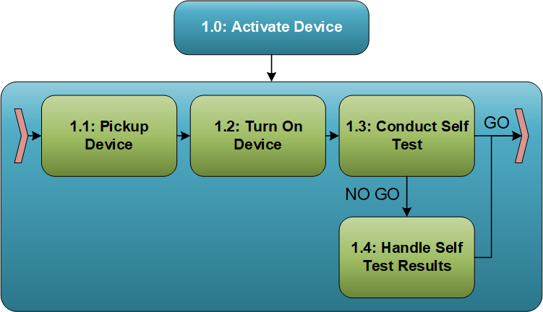

*Figure 7 – Diagram of Function 1.0: Activate Device*

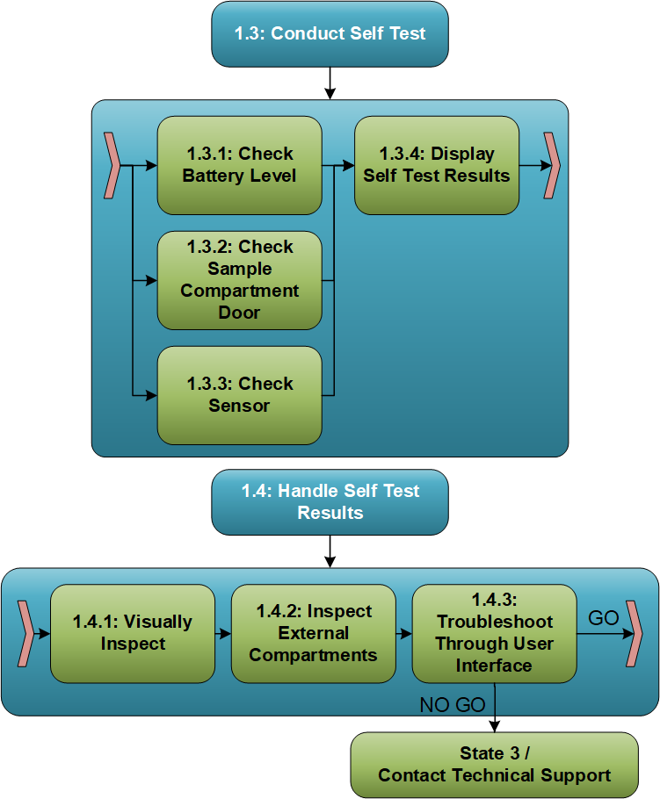

*Figure 8 – Diagram of Sub-Functions 1.3 & 1.4: Conduct Self Test & Handle Self Test Results*

If no faults are detected or the fault(s) are able to be corrected by the operator, the device will be ready to analyze a sample of the food product. Function 2 (Figure 6) is a combination of user and device functions that result in a food product sample being inserted into the device for analysis.

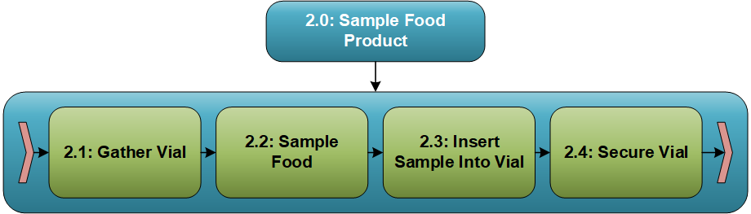

*Figure 9 – Diagram of Function 2.0: Sample Food Product*

With a sample inserted, the device will be ready to illuminate the sample with a laser, collect the resulting Raman vibrational spectra from molecules within the sample, process that spectra, and identify spectral characteristics that indicator the presence of E. coli (Figure 7).

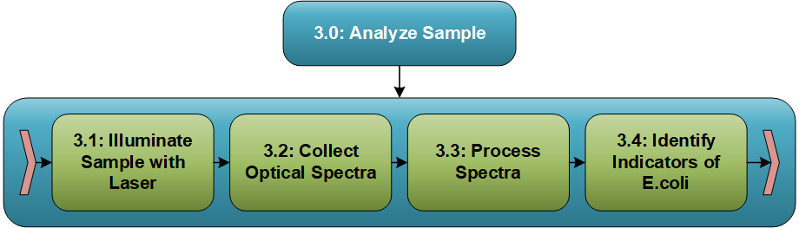

*Figure 10 – Diagram of Function 3.0: Analyze Sample*

Function 4 of the device (Figure 8) is to report to the operator the operator the results of the analysis, whether positive or negative for indicators of E. coli contamination. This information will be presented to the user on a visual display and via a audible tone.

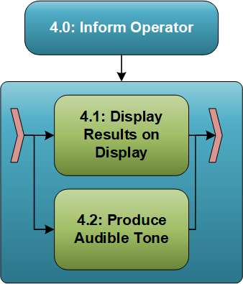

*Figure 11 – Diagram of Function 4.0: Inform Operator*

The results of the analysis along with sample metadata such as date and time will be stored in internal memory for future reference or auditing purposes (Figure 9).

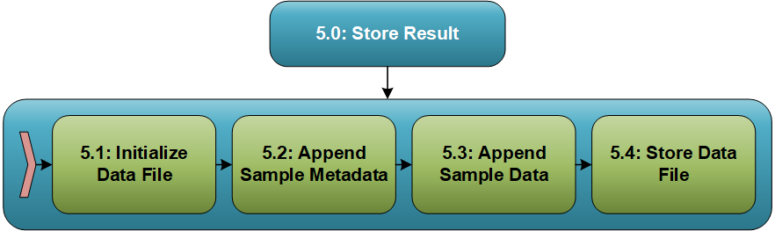

*Figure 12 – Diagram of Function 5.0: Store Results*

The device will enter a standby mode (Figure 10) after informing the user and storing the sample data. This low power-consumption mode will improve battery lifetime and overall device lifetime by deenergizing components and/or setting active components into a low-power state.

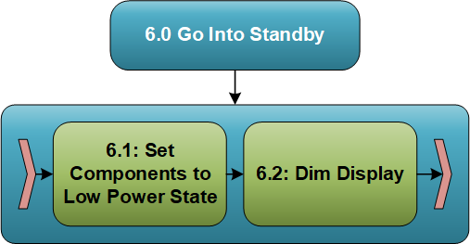

*Figure 13 – Diagram of Function 6.0: Go into Standby*

Function 7 (Figure 11) consists of a set of operator-performed functions intended to reduce the risk of sample cross contamination and will prolong the life of the device. The sample of food product contained in the disposable vial will be removed and thrown in the trash and the device will be manually sanitized.

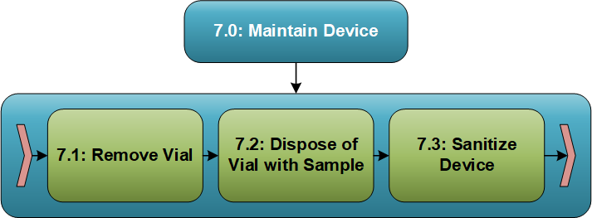

*Figure 14 – Diagram of Function 7.0: Maintain Device*

The system will perform functions in two additional states, as shown in Figure 2. As shown in Figure 12, State 2: Charge Battery has only one function, also named Charge Battery. State 3: Service Mode contains three functions required to maintain as usable and reliable system.

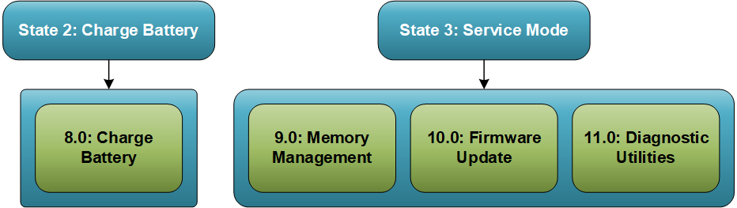

*Figure 15 – Diagrams of States 2 & 3: Charge Battery & Service Mode*

## System Requirements

Through an iterative approach of functional analysis, synthesis, and requirement derivation, we have developed the system and subsystem requirements listed in Table 2 - System Functional Requirements, Table 3 - System Performance Requirements, and Table 4 - System Design Requirements.

|  |  |  |
| --- | --- | --- |
| Index | Requirement | Derived From |
| 0F0001 | The system shall detect 1 CFU of harmful E-Coli. | Top-Level Requirements |
| 0F0002 | The system shall alert the user when done processing. | Top-Level Requirements |
| 0F0003 | The system shall operate untethered. | Top-Level Requirements |
| 0F0004 | The system shall be able to store prior readings onboard. | Top-Level Requirements |
| 0F0005 | The system shall allow for calibration checking. | Top-Level Requirements |
| 1F0001 | The device shall have a power button. | 0F0003 |
| 1F0002 | The device shall perform system checkup. | 0P0002 |
| 1F0003 | The device shall use disposable plastic vial. | 0P0002, 0P0004 |
| 1F0004 | The device shall be able to test on a small food sample. | 0D0002 |
| 1F0005 | The device shall interlock vial. | 0D0002 |
| 1F0006 | The device shall use IR Raman laser. | 0P0001, 0P0002, 0D0002, 0F0001, 0F0003 |
| 1F0007 | The system shall have programming capabilities for the user. | 0F0004 |
| 1F0008 | The system shall have programming capabilities for location. | 0F0004 |
| 1F0009 | The system shall have programming capabilities for food product. | 0F0004 |
| 1F0010 | The system shall have programming capabilities for vendor. | 0F0004 |
| 1F0011 | The system shall automatically insert date and time for each sample processed. | 0F0004 |
| 1F0012 | The system shall have internal storage to store 1000 test results. | 0F0004 |
| 1F0013 | The system shall automatically go into standby mode after being idle for 30 seconds. | 0F0003 |
| 1F0014 | The system shall reduce display brightness to 20% when on standby. | 0F0003 |
| 1F0015 | The system shall suspend processing when in standby mode. | 0F0003 |
| 1F0016 | The system shall reduce power consumption when in standby mode. | 0F0003 |
| 1F0017 | The system shall preserve data if it encounters battery or power failure. | 0F0004 |
| 1F0018 | The system shall have updateable firmware | Analysis |

*Table 7 - System Functional Requirements*

|  |  |  |
| --- | --- | --- |
| Index | Requirement | Derived From |
| 0P0001 | The system shall return a result within 5 seconds. | Top-Level Requirements |
| 0P0002 | The system shall have at least 98% accuracy. | Top-Level Requirements |
| 0P0003 | The system shall have a display brightness of greater than 750 lux. | Top-Level Requirements |
| 0P0004 | The system shall have an operational lifespan of 3 years. | Top-Level Requirements |
| 1P0001 | Fully charged batteries shall last for up to 100 tests. | 0D0002 |
| 1P0002 | The system batteries shall last up to 10 days in standby mode. | 0D0002 |
| 1P0003 | The system batteries shall take no more that two hours to fully charge. | 0D0002 |
| 1P0004 | The system shall operate in a temperature range of 32-140 deg F. | 0D0002 |

*Table 8 - System Performance Requirements*

|  |  |  |
| --- | --- | --- |
| Index | Requirement | Derived From |
| 0D0001 | The system shall have strong casing | Top-Level Requirements |
| 0D0002 | The system shall operate in typical restaurant environment. | Top-Level Requirements |
| 0D0003 | The system shall be WEEE compliant. | Top-Level Requirements |
| 0D0004 | The system shall be ergonomically suitable for users ranging from 5th percentile of females to the 95th percentile of males. | Top-Level Requirements |
| 1D0001 | The device shall be handheld. | 0F0003 |
| 1D0002 | The device shall be light (ergonomically designed). | 0F0003, 0D0004 |
| 1D0003 | The device shall have troubleshoot capabilities. | 0D0002 |
| 1D0004 | The system shall be IP-68 compliant. | 0D0002 |
| 2D0001 | The system shall have a LED capacitive touch display. | 0P0003, 0D0002, 1F0014 |
| 2D0002 | The system shall use Lithium ion batteries. | 1P0001, 1P0002, 1P0003 |

*Table 9 - System Design Requirements*

## Functional Requirement Allocation

The functional requirements specified in Table 2 have been allocated to the aforementioned functional architecture per Table 5.

|  |  |  |  |  |  |  |  |  |  |  |  |  |  |  |  |  |  |  |  |  |  |  |  |
| --- | --- | --- | --- | --- | --- | --- | --- | --- | --- | --- | --- | --- | --- | --- | --- | --- | --- | --- | --- | --- | --- | --- | --- |
| Function Number | Requirement Index | | | | | | | | | | | | | | | | | | | | | | |
| 0F0001 | 0F0002 | 0F0003 | 0F0004 | 0F0005 | 1F0001 | 1F0002 | 1F0003 | 1F0004 | 1F0005 | 1F0006 | 1F0007 | 1F0008 | 1F0009 | 1F0010 | 1F0011 | 1F0012 | 1F0013 | 1F0014 | 1F0015 | 1F0016 | 1F0017 | 1F0018 |
| 1.1 |  |  | X |  |  |  |  |  |  |  |  |  |  |  |  |  |  |  |  |  |  |  |  |
| 1.2 |  |  |  |  |  | X |  |  |  |  |  |  |  |  |  |  |  |  |  |  |  |  |  |
| 1.3 |  |  |  |  |  |  | X |  |  |  |  |  |  |  |  |  |  |  |  |  |  |  |  |
| 1.4 |  |  |  |  |  |  | X |  |  |  |  |  |  |  |  |  |  |  |  |  |  |  |  |
| 2.1 |  |  |  |  |  |  |  | X | X |  |  |  |  |  |  |  |  |  |  |  |  |  |  |
| 2.2 |  |  |  |  |  |  |  |  | X |  |  |  |  |  |  |  |  |  |  |  |  |  |  |
| 2.3 |  |  |  |  |  |  |  | X |  |  |  |  |  |  |  |  |  |  |  |  |  |  |  |
| 2.4 |  |  |  |  |  |  |  |  |  | X |  |  |  |  |  |  |  |  |  |  |  |  |  |
| 3.1 |  |  |  |  |  |  |  |  |  |  | X |  |  |  |  |  |  |  |  |  |  |  |  |
| 3.2 |  |  |  |  |  |  |  |  |  |  | X |  |  |  |  |  |  |  |  |  |  |  |  |
| 3.3 |  |  |  |  |  |  |  |  |  |  | X |  |  |  |  |  |  |  |  |  |  |  |  |
| 3.4 | X |  |  |  |  |  |  |  |  |  |  |  |  |  |  |  |  |  |  |  |  |  |  |
| 4.1 |  | X |  |  |  |  |  |  |  |  |  |  |  |  |  |  |  |  |  |  |  |  |  |
| 4.2 |  | X |  |  |  |  |  |  |  |  |  |  |  |  |  |  |  |  |  |  |  |  |  |
| 5.1 |  |  |  | X |  |  |  |  |  |  |  |  |  |  |  |  |  |  |  |  |  |  |  |
| 5.2 |  |  |  | X |  |  |  |  |  |  |  | X | X |  |  | X |  |  |  |  |  |  |  |
| 5.3 |  |  |  | X |  |  |  |  |  |  |  |  |  | X | X |  | X |  |  |  |  |  |  |
| 5.4 |  |  |  | X |  |  |  |  |  |  |  |  |  |  |  |  | X |  |  |  |  | X |  |
| 6.1 |  |  |  |  |  |  |  |  |  |  |  |  |  |  |  |  |  | X |  | X | X |  |  |
| 6.2 |  |  |  |  |  |  |  |  |  |  |  |  |  |  |  |  |  | X | X |  |  |  |  |
| 7.1 | X |  |  |  |  |  |  | X | X |  |  |  |  |  |  |  |  |  |  |  |  |  |  |
| 7.2 | X |  |  |  |  |  |  | X |  |  |  |  |  |  |  |  |  |  |  |  |  |  |  |
| 7.3 | X |  |  |  |  |  |  |  |  |  |  |  |  |  |  |  |  |  |  |  |  |  |  |
| 8.0 |  |  |  |  |  |  |  |  |  |  |  |  |  |  |  |  |  |  |  |  |  |  |  |
| 9.0 |  |  |  | X |  |  |  |  |  |  |  |  |  |  |  |  | X |  |  |  |  |  |  |
| 10.0 |  |  |  |  |  |  |  |  |  |  |  |  |  |  |  |  |  |  |  |  |  |  | X |
| 11.0 |  |  |  |  | X |  | X |  |  |  |  |  |  |  |  |  |  |  |  |  |  |  |  |

*Table 10 – Functional Allocation to System Design Requirements*

## Physical Architecture

The FADE system will be physically decomposed into six first level elements (Operator, Restaurant Owner/Manager, Device, Maintenance Equipment, Sampling Equipment, and Documentation) as shown in Figure 13. The Device element is further decomposed into five subsystems or components are shown in the figure.

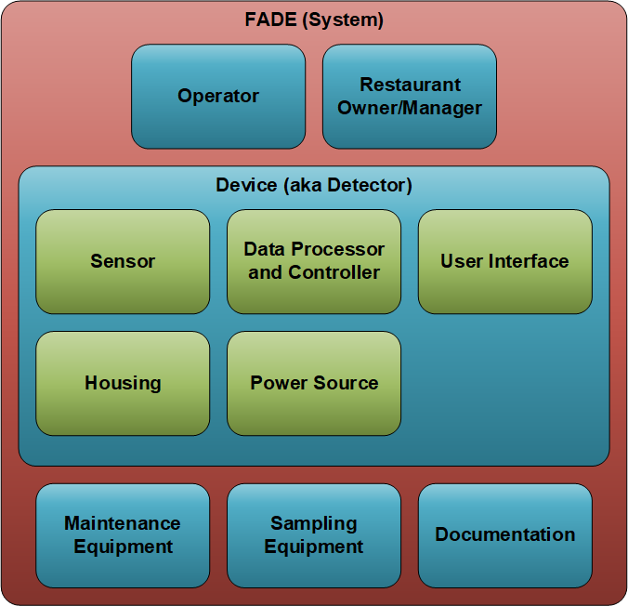

*Figure 16 – Physical Architecture*

The functional requirements specified in Table 2 have been allocated to the physical architecture per Table 5.

|  |  |  |  |  |  |  |  |  |  |  |
| --- | --- | --- | --- | --- | --- | --- | --- | --- | --- | --- |
| Function Number | FADE System | | | | | | | | | |
| Operator | Restaurant Owner/Manager | Device | | | | | Maintenance Equipment | Sampling Equipment | Documentation |
| Sensor | Data Processor and Controller | User Interface | Housing | Power Source |
| 1.1 | X |  |  |  |  | X |  |  |  | X |
| 1.2 | X |  |  |  | X |  | X |  |  | X |
| 1.3 |  |  | X | X |  |  |  |  |  | X |
| 1.4 |  |  |  | X | X |  |  |  |  | X |
| 2.1 | X |  |  |  |  |  |  |  | X | X |
| 2.2 | X |  |  |  |  |  |  |  | X | X |
| 2.3 | X |  |  |  |  |  |  |  |  | X |
| 2.4 | X |  |  |  |  | X |  |  |  | X |
| 3.1 |  |  | X |  |  |  |  |  |  |  |
| 3.2 |  |  | X |  |  |  |  |  |  |  |
| 3.3 |  |  |  | X |  |  |  |  |  |  |
| 3.4 |  |  |  | X |  |  |  |  |  |  |
| 4.1 |  |  |  | X | X |  |  |  |  | X |
| 4.2 |  |  |  | X | X |  |  |  |  | X |
| 5.1 |  |  |  | X |  |  |  |  |  |  |
| 5.2 |  |  |  | X |  |  |  |  |  |  |
| 5.3 |  |  |  | X |  |  |  |  |  |  |
| 5.4 |  |  |  | X |  |  |  |  |  | X |
| 6.1 |  |  | X | X | X |  | X |  |  | X |
| 6.2 |  |  |  |  | X |  |  |  |  | X |
| 7.1 | X |  |  |  |  | X |  |  |  | X |
| 7.2 | X |  |  |  |  |  |  |  |  | X |
| 7.3 | X |  |  |  |  |  |  | X |  | X |
| 8.0 | X |  |  |  |  |  |  | X |  | X |
| 9.0 |  | X |  | X | X |  |  | X |  | X |
| 10.0 |  | X |  | X | X |  |  | X |  | X |
| 11.0 |  | X |  | X | X |  |  | X |  | X |

*Table 11 – Functional Allocation to Physical Architecture*

# Detail Design Phase

## Risk Managment

Five major risks were identified for FADE ranging from moderate to high risk. Such risk involved performance, supply chain support, obsolescence, and safety. In the table below, each risk is evaluated by both impact and likelihood to occur. The high-risk items are the possibility of having a sole source supplier and sensor miniaturization.

**Risk Level Rationale**

**Risk 1: Sensor Miniaturization**

Multiple researchers have demonstrated that Raman spectroscopy can detect E. coli. However, the illumination and detection instruments used have typically been laboratory grade and not handheld. In order to be successful, newer, less proven technology, such as MEMS optical spectrometers, will need to be integrated.

**Risk 2: Standard Compliance and Certification**

The equipment will need to pass both typical consumer electronics testing (e.g. UL and CE) and NSF testing due to intended use in restaurants. The development team is quite familiar with consumer electronics certifications but this will be their first time designing equipment to pass NSF testing, making it possible the equipment will not pass compliance testing and need to be revised.

**Risk 3: Radiation Exposure**

Raman testing is done by illuminating food sample with a laser beam. The electromagnetic radiation from the illuminated spot is collected with a lens and fed to a detector. The beam paths must be fully enclosed to prevent the risk of exposure. If it is not contained, the user could be harmed.

**Risk 4: Obsolescence**

The equipment will likely use specialized COTS components--for example a miniaturized optical spectrometer--and embedded electronics. These types of components are commonly updated by the manufacturer with older models being retired, no longer manufactured, and unavailable for procurement as spare parts. This situation could lead to the inability to maintain and repair units.

**Risk 5: Sole Source**

It is reasonable to design FADE for usage of COTS material, such as power cables, LED screens, and fasteners, however, there still exists the likelihood that at least one single/sole source supplier will be unavoidable depending on the business case for designing and programming in house versus contracting outside the business. Also, limited capable and qualified supplier to produce the detection hardware could create an unavoidable single/sole source situation.

|  |  |  |  |  |  |  |  |  |
| --- | --- | --- | --- | --- | --- | --- | --- | --- |
|  | | **Category** | | | | | |  |
| **Risk #** | **Risk Description** | Likelihood | Consequence | Technical | Schedule | Cost | **Priority** | **Risk Handling (Mitigate, Avoid, Transfer, Share, or Retain)** |
| 1 | Sensor Miniaturization: If an E. coli detecting IR Raman subsystem cannot be miniaturized to fit within a handheld instrument then the equipment will not meet both the accuracy and usability system requirements. | 3 | 5 | X |  |  | **HIGH** | Mitigate: Pursuing options of using other existing miniature lasers and optical spectrometry, or use MEMS and other technologies to reduce size of IR sensor and make it feasible for handheld device |
| 2 | Standard Compliance and Certification:If first-production units do not pass the first round of NSF International compliance testing then additional design and, more impactfully, expensive and lengthy third-party testing will have to be repeated. | 3 | 4 |  | X | X | **MOD** | Mitigate: Early and constant involvement in the development effort by the company compliance/quality engineer. |
| 3 | Radiation exposure: If the device doesn't have a safety technique to prevent the user from illuminating Raman laser beam then this may result in radiation exposure causing severe damages to affected individual(s). | 2 | 5 | X |  |  | **MOD** | Mitigate: Use of high density polyethylene vials with interlock safety trigger that will allow laser beam illumination only when tightly connected with the vial. |
| 4 | Obsolescence: If technology changes during the life of the device, then this will affect product manufacturability and maintainability which may require product redesign. | 3 | 4 | X |  |  | **MOD** | Avoid: Use of commercial off the shelf (COTS) products with a broader range of usage ensures that the product remains in the market due to its applicability, and when it becomes obsolete it is replaced with an improved version. |
| 5 | Sole Source: If a sole source supplier fails to perform, then the supplier issues could result in schedule delays, increase cost, and the end of production and/or sustainment. | 5 | 4 |  | X | X | **HIGH** | Mitigate: Proactive supplier management and planning from integrated product team to ensure on time delivery and quality, and designing for COTS items will reduce the need for single-sourced suppliers. |

*Table 12- Risk Management*

|  |  |  |  |  |  |  |
| --- | --- | --- | --- | --- | --- | --- |
| **Likelihood** | Almost Certain  (5) |  |  |  | **Risk 5** |  |
| Likely (4) |  |  |  |  |  |
| Possible (3) |  |  |  | **Risk 2**  **Risk 4** | **Risk 1** |
| Unlikely (2) |  |  |  |  | **Risk 3** |
| Rare (1) |  |  |  |  |  |
|  | | Insignificant (1) | Minor (2) | Moderate (3) | Major (4) | Catastrophic (5) |
| **Consequence** | | | | |

*Table 13 - Risk Cube*

## 

## Verification Plan

Technical performance measures, method of verification, and requirement each measure is derived from.

|  |  |  |
| --- | --- | --- |
| **TPM** | **Requirement Derived From** | **How Measured/Monitored** |
| Verification of a false positive performance | 1.  The system shall detect 1 CFU of harmful E. Coli  4.  The system shall have 98% accuracy | Metric: % of Type 1 errors in testing.  An evaluation program to be used throughout the design phase using calibrated reference samples. Subsystem and component designers will be required to report the performance of their components against these references at major design review. |
| Verification of a false negative performance | 1.  The system shall detect 1 CFU of harmful E. Coli  4.  The system shall have 98% accuracy | Metric % of Type 2 errors in testing.  A similar test used for TPM1 will be used to verify device detects greater than 1 cfu at a likelihood of greater than 99.8% of trials.  Device must meet this criteria at every major milestone. PV and SORP milestones will also be verified by a third party. |
| Device durability | 7.  The system shall operate in a typical restaurant environment  11.  The systems shall have an operational lifespan of 3 years | Metric: MTBM estimate.  Each iteration of components will be tested against impact, vibration, thermal shock, and chemical resistance. Major milestones will require both component and device level testing. |
| Measurement detection time | 2.  The system shall return a result within 5 seconds | Metric: Detection time.  PV must meet final target and will be performed in house. Performance will be verified with random samples after SORP by third party.  Test will be performed with less than 10 CFU. |

*Table 14 – Technical Performance Measures*

# Production Phase

## 3.1 Production

As the program shifts from the detail design phase into production, transition activity needs to occur. Such activity includes preparing suppliers and setting up the production lines. First article inspections, supplier purchase contracts, part schedule/delivery, and initial quality checks are needed to ensure no gaps in supply chain support at the start of production is required, as this is a vulnerable time since any miscommunication and issues at supplier start-up surface in the beginning phases. Such issues need to be identified and addressed promptly to protect schedule. Any issues that cannot be resolved to the desired standard needs to be expressed such that the production schedule can be adjusted appropriately.

To increase capacity. the production line needs to be designed to create the best flow, yielding efficiencies for each station such that there is minimal waste (such as manpower idle time, scrapped material, excess material handling, unplanned work stoppage, etc.) Removing such waste and using time studies and plant layout design techniques increase efficiencies, therefore, allows the production line to build more units per shift.

## 3.2 Cost

Along with increasing capacity, leaning out production saves money, making operating costs lower, and in return, making the cost to build the unit cheaper. The example of idling manpower demonstrates how waste can be transformed into earnings. When there is bottlenecking in the production line, production workers down the line are waiting at their station for work to flow through. As they wait, they are being paid to not put out useful work. When this bottlenecking is designed out of the flow, each production worker is never waiting, and instead continuously building the unit that will be shipped to a customer.

Cost will be driven by different categories over the life of the program, as demonstrated in Figure 14 - Cost and Schedule. For instance, the conceptual design phase will utilize all engineering hours and no production labor or material. As the program transitions to the right, less engineering labor and more material and production labor will be required. Such wrap rates will impact the cost to create and deploy the final product. Once all major factors are calculated, the unit price is quoted at $1,770, successfully achieving the goal to keep the unit below $2,000 such that the unit is affordable to the end customer. Pricing assumptions and calculation can be seen in Table 10 - Cost Assumptions and Figure 15 – Cost Calculations

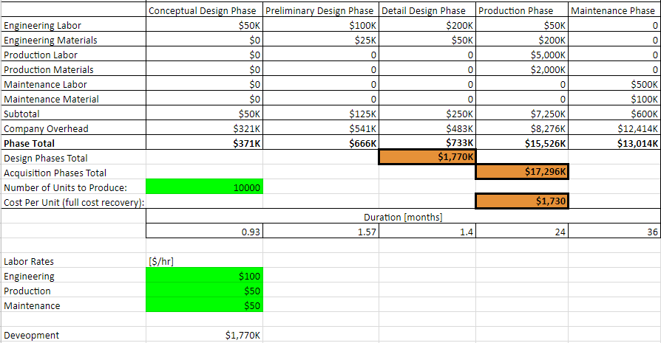

*Figure 17 - Cost and Schedule*

|  |
| --- |
| 8 hour office days |
| Two 8 hour production shifts |
| 10 production employees per line |
| 5 engineers |
| Other disciplines such as HR, Finance, etc. not included* |
| One production line open per shift |
| Annual OH cost is 3M |
| 261 working days/year |
| 3% inflation per year |
| *HR, Finance, and other disciplines are included in the OH charges. |

*Table 15 - Cost Assumptions*

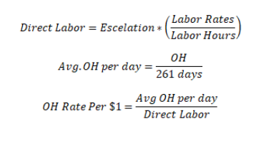

*Figure 18 – Cost Calculations*

# Maintenance Phase

Maintenance and cleaning are the responsibility of device operator and are clearly defined in supplied user manual. If for any reason the device malfunctions the figure below illustrates the support procedure.

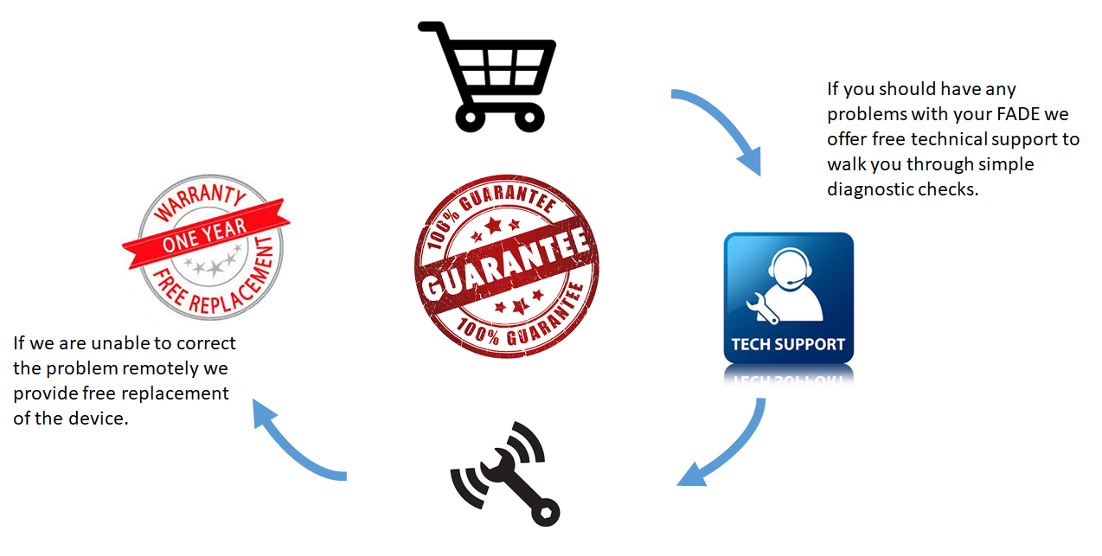

*Figure 19 – Aftersales Support*

# References

Amanatidou, A., et al. “Effect of elevated oxygen and carbon dioxide on the surface growth of vegetable – Associated micro-Organisms.” *Journal of Applied Microbiology*, vol. 86, no. 3, 1999, pp. 429-438., doi:10.1046/j.1365-2672.1999.00682.x.

Athamneh, A. I. M., et al. “Phenotypic Profiling of Antibiotic Response Signatures in Escherichia coli Using Raman Spectroscopy.” *Antimicrobial Agents and Chemotherapy,* vol. 58, no. 3, Feb. 2013, pp. 1302-1314., doi:10.1128/aac.02098-13.

Baanto International Ltd. (n.d.). Multi touch screen technology -digital signage and large format touch displays.  Retrieved September 16, 2017, from <http://baanto.com/>

Cheng, Jun-Hu, and Da-Wen Sun. “Recent Applications of Spectroscopic and Hyperspectral Imaging Techniques with Chemometric Analysis for Rapid Inspection of Microbial Spoilage in Muscle Foods.” *Comprehensive Reviews in Food Science and Food Safety*, vol. 14, no. 4, Ap. 2015, pp. 478-490., doi:10.1111/1541-4337.12141.

Davis, T. (2003, October 08). Reducing capacitive touchscreen cost in mobile phones.  Retrieved September 16, 2017, from <http://cypress.com/documentation/technical-articles/reducing-capacitive-touchscreen-cost-mobile-phones>

Hamasha, Khozima, et al. “Sensitive and specific discrimination of pathogenic and nonpathogenic Escherichia coli using Raman spectroscopy – a comparison of two multivariate analysis techniques.” *Biomedical Optics Express*, vol. 4, no. 4, Jan. 2013, p. 481., doi:10.1364/boe.4.000481.

Kammies, Terri-Lee, et al. “Differentiation of foodborne bacteria using NIR hyperspectral imaging and multivariate data analysis.” *Applied Microbiology and Biotechnology*, vol. 100, no. 21, 2016, pp. 9305-9320., doi:10.1007/s00253-016-7801-4.

Larkin, Peter. Infrared and Raman Spectroscopy : Principles and Spectral Interpretation, Elsevier Science, 2011. ProQuest Ebook Central.

Poupyrev, I., & Maruyama, S. (2003, November). Tactile interfaces for small touch screens. In *Proceedings of the 16th annual ACM symposium on User interface software and technology* (pp. 217-220). ACM.

Radke, Stephen M., and Evangelyn C. Alocilja. “A high density microelectrode array biosensor for detection of E. coli O157:H7.” *Biosensors and Bioelectronics*, vol. 20, no. 8, Nov. 2004, pp. 1662-1667., doi:10.1016/j.bios.2004.07.021.

Varisanga, M.d, et al. “Comparison of the effects of using standard and simple portable CO2 incubators on the in virto developmental competence of bovine embryos reconstituted by somatic cell nuclear transfer.” *Theriogenology*, vol. 58, no. 1, 2002, pp. 77-86., doi:10.1016/s0093-691x(02)00909-3.

Velusamy, Vijayalakshmi, et al. “An overview of foodborne pathogen detection: In the perspective of biosensors.” *Biotechnology Advances*, vol. 28, no. 2, 2010, pp. 232-254., doi:10.1016/j.biotechadv.2009.12.004.